Computer Language Coding Concepts

Assignment in a Diagram
The principle of assignment is explained in the article Assignment. This article demonstrates the expression of it in a diagram.

There are several types of assignment, for instance value assignment and object assignment. All assignments are displayed as a call to a special system command: an assignment command. An assignment command has two parameters: the source and the target.

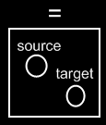

The source is a Reference In parameter, the target is a Reference Output parameter. The parameter types can be shown as follows in a diagram of an assignment command definition:

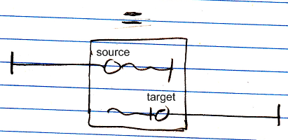

The notation of the different parameter types is discussed in the article In, Out, Thru & Downput Parameters.
A call to the assignment command would look like this:

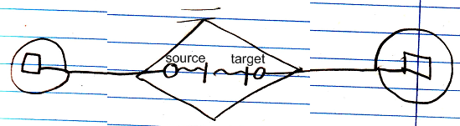

But assignment is so fundamental and common, that is is given a more basic notation, like the following:

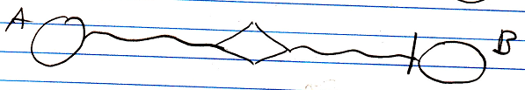

This is a value assignment. The value of object A is assigned to object B. The line type indicates what type of assignment it is. The access mark indicates the direction of the assignment. The command name is not displayed (=), the parameters are not displayed and the object commands are not displayed.
The below is an object assignment:

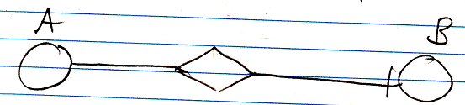

The solid line is what makes it an object assignment. The target object of symbol A is assigned to symbol B.

See also: Assignment, In, Out, Thru & Downput Parameters in a Diagram

Author & Copyright: Jan-Joost van Zon Date: May 25, 2008 – June 12, 2008 Location: Oosterhout, The Netherlands Status: Finished

